 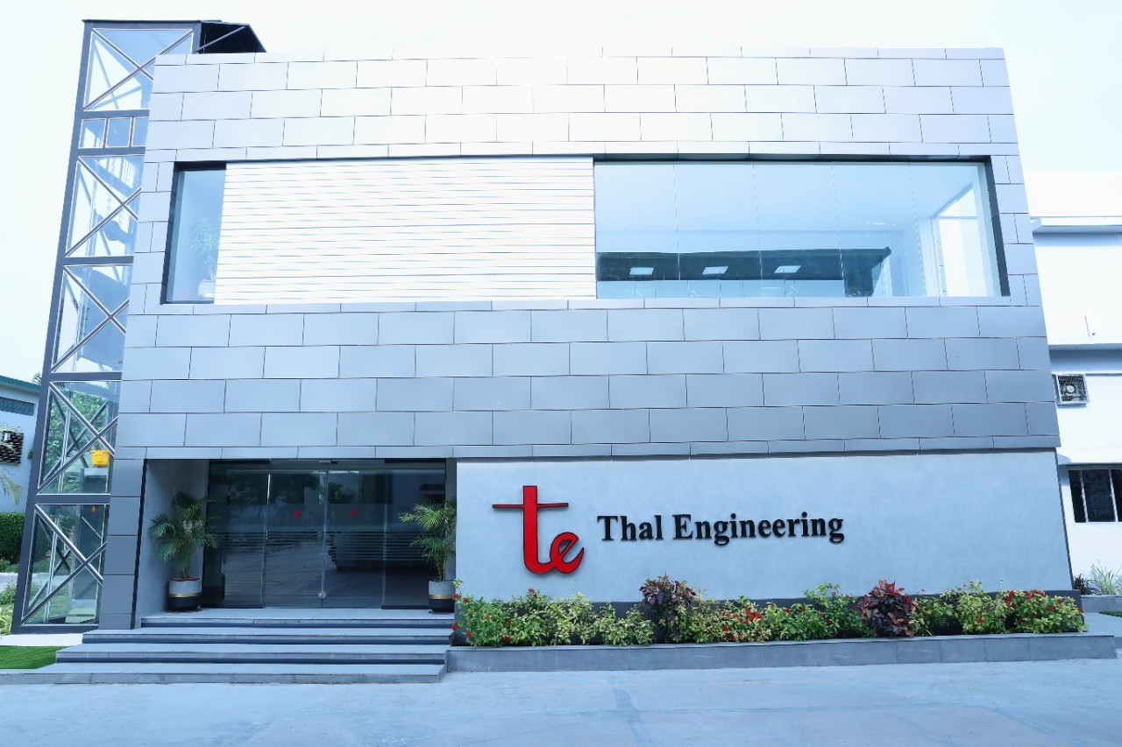

**1- ECONOMICAL AND POLITICAL REVIEW:**

Thal Limited (THALL) was incorporated in Pakistan as a public limited company in 1966. The principal activity of the company is the manufacturing of jute goods, engineering goods, laminate sheets and paper sacks.

In 2020, THALL's topline enrolled a 26 percent year-on-year plunge. The organization's designing fragment posted a 46 percent year-on-year decrease in income in 2020 on the rear of contracted request of vehicle industry. This was by virtue of Pak Rupee deterioration and the burden of extra obligations and expenses which expanded the auto costs. The drop in car deals was additionally exacerbated by the episode of Coronavirus. As against designing fragment, bundling, building materials and united items section posted a 12 percent year-on-year ascend in income in 2020 primarily because of an uplifting interest of paper sacks because of ascend in web-based deals and an upgraded center around fastidious bundling during the lockdown time frame. Inferable from the developing interest, the organization likewise updated its concrete sack fabricating plant during the year and introduced a creation line. Cost of deals drooped by 23% year-on-year in 2020 which converted into a 39 percent lower net benefit and GP edge tumbling down to 15.4 percent. Working cost mounted by 12% in 2020 because of raised cargo cost. Lower provisioning against WWF and WPPF moved other cost somewhere near 53% year-on-year in 2020. Other pay additionally shrank by 27% year-on-year in 2020 fundamentally because of lower profit pay. Working benefit shrunk by 45% year-on-year in 2020 with Over powered edge falling to 14.4 percent. Finance cost took off by 72% in 2020 which was especially because of higher bank charges and commissions. Net benefit drooped by 41% year-on-year in 2020 to time in at Rs.1,867.16 with NP edge slipping to 11.2 percent and EPS of Rs.23.04.

In 2021, THALL's net deals enrolled areas of strength for an of 64.6 percent. This was on the rear of an impressive 100% year-on-year ascend in the income from designing fragment as the vehicle area flourished during the year because of markdown rate cuts, monetary recuperation after the simplicity of lockdown as well as section of new market players like Hyundai Nishat Engine (Private) Restricted and Expert Engine Corporate (Private) Restricted which expanded the quantity of options accessible to the customers. Bundling, assembling and unified items industry additionally developed by 31% year-on-year in 2021 because of higher product deals. Cost of deals spiked by 61% in 2021, yet better volume and moderate valuing finished into 83% greater net benefit in 2021 versus earlier year. GP edge likewise got to 17.1 percent in 2021. Working cost amplified by 27% year-on-year in 2021 principally because of extremely higher cargo cost and arrangement for guarantee commitments. Other cost heightened by 84% year-on-year in 2021 because of higher benefit related provisioning.THALL's cost were nearly counterbalanced by 48% higher other pay procured by the organization in 2021. This converted into a 93 percent higher working benefit in 2021 with Over powered edge scaling to 17 percent. Finance cost spiked by 106% in 2021 because of expanded present moment and long haul borrowings got during the year. Net benefit further developed by 86% year-on-year in 2021 to time in at Rs.3,482.20 with EPS of Rs.42.97 and NP edge of 12.7 percent.

THALL's topline developed by one more 37 percent in 2022. This was supported by 42% increment in the income from designing portion because of expanded auto deals in the 1HFY22. Nonetheless, in the last 50% of the year, the nation saw reducing unfamiliar trade saves because of rising product costs in the result of Russia-Ukraine emergency and furthermore on account of postpone in the IMF program. The other section of THALL additionally posted 29% ascent in its income in 2022 on the rear of expanded request of Pakistan grain sacks in the commodity market. Cost of deals climbed by 36% year-on-year on the rear of high product costs, Pak Rupee deterioration as well as climb in power duty and general inflationary pattern in the economy. In any case, the organization had the option to work on its gross edge to 17.4 percent by giving the onus of raised cost to its customers somewhat. Working cost mounted by 21% in 2022 because of higher cargo cost, arrangement for guarantee commitments and raised finance cost because of expansion in the quantity of representatives from 4367 out of 2021 to 5194 out of 2022. Higher trade misfortune moved other cost up by 87% in 2022. Other pay developed by 11% year-on-year in 2022 because of elevated profit pay and interest pay. Working benefit rose by 32% year-on-year in 2022, be that as it may, Over powered edge somewhat tumbled to 16.3 percent. Finance cost duplicated by a gigantic 316 percent in 2022 by virtue of high rebate rate and furthermore in view of expanded borrowings which fundamentally expanded its obligation to-value proportion from 1.87 percent in 2021 to 10.54 percent in 2022. This essentially weakened the bottomline. In 2022, THALL's net benefit walked up by 22% year-on-year to time in at Rs. 4,257.25 million with EPS of Rs.52.54 and NP edge of 11.4 percent.

**2- ABOUT COMPANY:**

Thal Limited has the distinction of being the flagship industrial project of the group. Incorporated in 1966 as Thal Jute Mills Limited, the company renamed itself as Thal Limited in 2004 as part of the organization’s consolidation strategy. Currently the company manages two distinct businesses: the engineering business and the building material & packaging business. The Engineering division of Thal Limited owns and operates the Electrical Systems business; the Thermal Systems business and the Engine Components business. The Electrical Systems business is involved in manufacturing a wide range of wiring harness products from simple cable preparation to highly complex wiring harnesses, cable assemblies, and battery cables mainly for the Automotive industry. The business came into existence in the year 2000 with the signing of a TAA (Technical Assistance Agreement) with Furukawa Electric Company, Japan. Furukawa is one of the leading suppliers of automotive wiring harness systems in the world. Moreover, during the current year, the Company’s Engineering Segment, laid the foundations for a new plant to cater to expansion in its automotive wire harness business in technical collaboration with Yazaki Corporation, one of the world’s largest automotive parts suppliers. The combined synergies of both the companies would enable the business to establish itself in a relatively quick span of time as a premier supplier of car wiring systems to all automobile manufacturers in Pakistan. The Thermal Systems – which commenced operations in 1996 – manufactures Auto Air Conditioners for Toyota and Suzuki vehicles manufactured and assembled in Pakistan. Ever since its establishment, Thal Engineering's Thermal Systems division has remained progressive with the addition of multiple capabilities unto its fold. To deliver a product range of excellent quality, the Company entered into a Technical Assistance Agreement with Denso Japan in 1996 – the second largest auto parts maker in the world – listed on the Fortune 500 and the largest in Japan. The strategic alliance has acquired and obtained world class assistance in manufacturing car air conditioners, heater blowers & now aluminum radiators, enabling the business to continue in its growth trajectory. The Engine Components – although a relatively newer addition to Thal Engineering Limited – manufactures Starters and Alternators for Toyota vehicles. The business was established with a clear vision to localize and manufacture automobile engine parts and components for different automobile OEMs in Pakistan. The business has the unique distinction of being the first and foremost manufacturer of Engine Starters and Alternators for passenger cars in Pakistan under a foreign collaboration. Thal Limited also owns and operates the building material and packaging businesses which comprises of laminates, Jute, Paper sack and Woven Polypropylene packaging. The Laminates business was established in 1980 as the first of its kind manufacturing unit for the production of high-pressure decorative laminates in Pakistan under the brand name of FORMITE. Today, the Company remains a market leader for its range of decorative and electrical grade compact laminates. Over the years, the business has successfully integrated upstream and downstream facilities to maintain its competitive edge and remain a partner of choice for a wide variety of stakeholders both locally and abroad. The Jute business bears the honor of being the first industrial project that was undertaken by House of Habib. Located in the heart of Punjab, nestled between the banks of River Indus and Chenab, the Company is involved in manufacturing of grain sacks in various grades including food grade and Hessian yarn & twine for domestic and export markets. The Paper sack business has been in operation since the 1970s, is the pioneering multi-ply manufacturing unit in Pakistan and has remained a market leader in the business since its inception. With the strategic locations of its plants situated in Hub (Baluchistan) and Gadon (Khyber-Pakhtunkhwa), the Company has an annual production capacity of 150 million sacks. With close to five decades of world class product leadership, the paper sack business not only fulfills local demand but also exports to key international markets including Middle East, India, EU and the UK amongst other avenues. In 2022, the Packaging business expanded by starting a commercial operation with the state-of-the-art Woven Polypropylene (“WPP”) line on European based technology on integrated machines which was procured from Windmöller & Hölscher. This latest technology has an annual production capacity of 90 million bags and has the ability to provide highest quality of printing, with one of its kind high gloss finishes having high quality imprints Both the packaging solutions cater to various industries that include cement, chemicals and dyes, bonding adhesives, industrial salt, calcium, gypsum, carbon black, milk powder and guar gum amongst others. Since our inception we have continued to touch and redefine life through the spectrum of our businesses that continue to impact a broad category of stakeholders in innumerable ways. To provide further impetus to our growth. philosophy we continue to diversify our investments with an ever-expanding footprint in subsidiaries such as Noble Computer Services (Private) Limited, Pakistan Industrial Aids (Private) Limited, Habib METRO Pakistan (Private) Limited, Thal Boshoku Pakistan (Private) Limited and Thal Power (Private) Limited. In addition, the Company also shares investments in associates like Indus Motor Company Limited, Habib Insurance Company Limited, Agri auto Industries Limited, Shabbir Tiles and Ceramics Limited. Cognizant of our responsibility to the country and mapping our investments with solving the critical issues the economy faces, our recent most investment has been in Sindh Engro Coal Mining Company (SECMC) – a landmark project to fuel the growth of Pakistan’s economy and develop indigenous energy resources. To bolster this investment Thal Limited has also entered into a Joint Venture Agreement with Novatex Limited to develop a 330 MW coal-fired power plant at Thar – an investment we feel will curtail the energy crisis and help bring positive impact to the communities around us. In October 2018 Hubco joined Thal Nova as a 38.3% shareholder.



**COMPETITORS OF THALL LIMITED:**

* **ARTISTIC DENIM MILLS**
* **AGRI AUTOS INDUSTRIES LIMITED**
* **BALOCHISTAN WHEELS LIMITED**

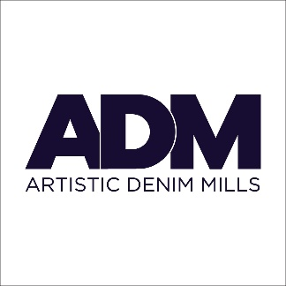

ADM Denim is a Premium Denim Producer. The company is public listed and started production in 1993. Current capacity is three Million yards of Fabric and one million pairs of jeans per month. ADM is a complete vertical unit converting Cotton to Finished Garments.  
On the fabric side, our product range includes weights from 8 oz up to 14 oz using multi-count/multi-twist ring/open-end yarns using AMSLER technology. We have two rope indigo dye ranges, which are capable of doing colored bottoming/topping plus very deep indigo shades. Weaving is done on machines from Switzerland and Italy. We have latest flat finishing machines designed to give denim constructed denim look and clear optics. Our medallion finishes foam coats denim with resin or color pigment to give 3-dimensional effect. We produce denim using 100 % cotton, 99% Cotton 1% Lycra, and T400 Invista Fiber.  
On the garment side, we produce 5-pocket jeans for well know brands in Europe and the United States. The infrastructure includes computerized cutting tables, specialize robotic jeans sewing equipment, and TONELLO washing machines. Highly trained staff operates our laundry with quarterly visits from Italian experts for collection development.



|  |  |
| --- | --- |
| Agriauto Industries Limited is a public limited company incorporated in 1981 and quoted on the stock exchange. The company is one of the leading automotive components manufacturers in the private sector and the first company in Pakistan to acquire TS16949 certification. |  |
| Technical Collaborations with leading international companies have added to the company’s technical versatility. The product range covers both original equipment manufacturers (OEM) and aftermarket. | |

Hub Chowki, Distt, Lasbella, Balochistan, Pakistan.



Located in the industrial zone of Hub about 35 kilometers from Karachi, Baluchistan Wheels Limited was setup in 1980 for the manufacturing of steel wheels for automobiles with technical collaboration of GKN Sankey Limited UK. The plant has a covered area of 16,000 square meters and builds on a land of 97,000 square meters. It has the capability to manufacture diverse range of wheels for passenger cars, commercial vehicles, agricultural tractors and 4x4 vehicles. The company is a corresponding member of European Tyre & Rim technical Organization (ETRTO) and its quality management system is certified for ISO-9002 by AIB Vincotte of Belgium.

**3- COMPARATIVE ANALYSIS**

**FINANCIAL RATIO WITH TREND ANALYSIS**

|  |  |  |  |  |
| --- | --- | --- | --- | --- |
| **Current Ratio** | | | | |
|  | **THALL** | **ADMM** | **AGIL** | **BWHL** |
| **2022** | 2.7 | 1.17 | 1.99 | 4.13 |
| **2021** | 3.24 | 1.23 | 3.22 | 4.61 |
| **2020** | 4.2 | 1.41 | 3.3 | 7.72 |

**GRAPHICALLY:**

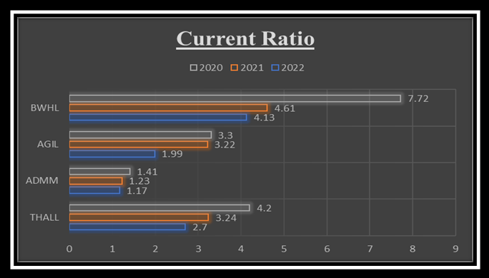

**INTERPRETATION:**

The current ratio measures a company's ability to cover its short-term liabilities with its short-term assets. Looking at the data for the years 2020 to 2022, we observe that THALL's current ratio has decreased from 4.2 in 2020 to 2.7 in 2022, indicating a potential decline in its short-term liquidity. ADMM's current ratio has also seen a decrease from 1.41 in 2020 to 1.17 in 2022, suggesting a similar trend. AGIL's ratio has dropped from 3.3 in 2020 to 1.99 in 2022, indicating a potential challenge in meeting short-term obligations. On the other hand, BWHL's current ratio has remained relatively stable, going from 7.72 in 2020 to 4.13 in 2022, suggesting a comparatively stronger ability to cover short-term liabilities. Overall, a declining current ratio may signal potential liquidity concerns, while a stable or improving ratio indicates a healthier short-term financial position.

|  |  |  |  |  |
| --- | --- | --- | --- | --- |
| **Quick Ratio** | | | | |
|  | **THALL** | **ADMM** | **AGIL** | **BWHL** |
| **2022** | 1.35 | 0.59 | 0.94 | 2.61 |
| **2021** | 1.78 | 0.59 | 2.17 | 3.4 |
| **2020** | 2.39 | 0.88 | 1.48 | 4.78 |

**GRAPHICALLY:**

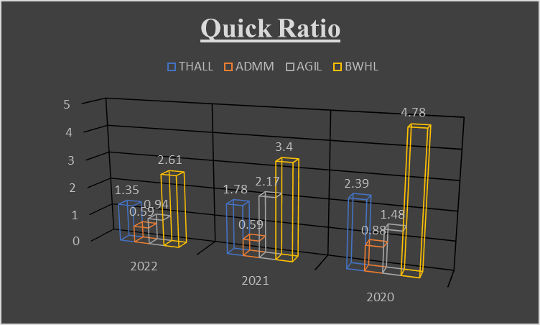

**INTERPRETATION:**

The quick ratio, a measure of how well a company can pay its short-term debts with its readily available assets, was calculated for four companies—THALL, ADMM, AGIL, and BWHL—over the years 2020, 2021, and 2022. A quick ratio above 1 indicates a company has enough easily accessible assets to cover its short-term debts. For THALL, the quick ratio decreased from 2.39 in 2020 to 1.35 in 2022, suggesting a potential reduction in liquidity. ADMM maintained a relatively stable quick ratio around 0.59, while AGIL experienced a decrease from 2.17 in 2021 to 0.94 in 2022. On the other hand, BWHL showed an increase from 4.78 in 2020 to 2.61 in 2022, indicating improved liquidity. These ratios provide insights into each company's financial health and ability to meet immediate financial obligations.

|  |  |  |  |  |
| --- | --- | --- | --- | --- |
| **Debt to Equity Ratio** | | | | |
|  | **THALL** | **ADMM** | **AGIL** | **BWHL** |
| **2022** | 11.21 | 141.9 | 17.7 | 1.72 |
| **2021** | 23.54 | 160.82 | 23.21 | 18.47 |
| **2020** | 15.38 | 122.03 | 19.71 | 16.53 |

**GRAPHICALLY:**

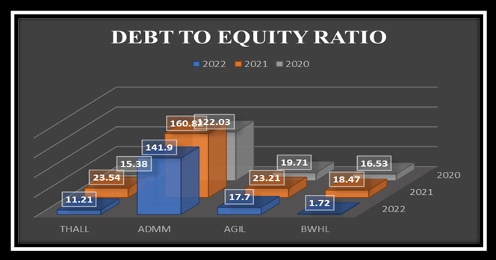

**INTERPRETATION:**

The Debt-to-Equity Ratio measures how much a company relies on debt compared to equity for its financing. Looking at the provided data for the years 2020, 2021, and 2022, we can see that for THALL, the ratio decreased from 15.38 in 2020 to 11.21 in 2022. For ADMM, it increased from 122.03 in 2020 to 141.9 in 2022. AGIL's ratio fluctuated from 19.71 in 2020 to 23.21 in 2021, then decreased to 17.7 in 2022. Unfortunately, there isn't enough information to calculate the ratio for BWHL due to missing data on Total Debt and Shareholders' Equity. Overall, the Debt-to-Equity Ratio provides insights into a company's financial structure and its ability to meet financial obligations.

|  |  |  |  |  |
| --- | --- | --- | --- | --- |
| **Price Earnings Ratio** | | | | |
|  | **THALL** | **ADMM** | **AGIL** | **BWHL** |
| **2022** | 7.08 | 10.12 | 23.96 | 4.86 |
| **2021** | 9.76 | 22.01 | 10.08 | 9.83 |
| **2020** | 13.67 | 40.65 | -171.02 | 39.21 |

**GRAPHICALLY:**

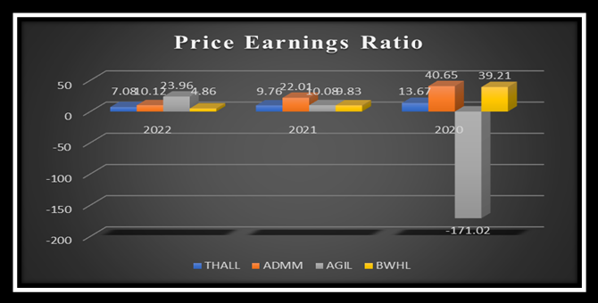

**INTERPRETATION:**

The Price-Earnings Ratio (P/E Ratio) for different companies in 2020, 2021, and 2022 shows how their stock prices relate to their earnings. For THALL and ADMM, their P/E ratios decreased from 2020 to 2022, indicating potential lower growth expectations or increased earnings. AGIL's P/E ratio significantly increased, suggesting higher growth expectations or increased confidence. BWHL's P/E ratio decreased, indicating a potential decrease in growth expectations or an increase in earnings. Negative P/E ratios, like AGIL's in 2020, are unusual and might result from negative earnings. Investors should consider various factors and industry benchmarks when using P/E ratios to make investment decisions.

|  |  |  |  |  |
| --- | --- | --- | --- | --- |
| **Equity To Assets Ratio** | | | | |
|  | **THALL** | **ADMM** | **AGIL** | **BWHL** |
| **2022** | 72.41 | 36.05 | 67.53 | 83.41 |
| **2021** | 80.94 | 38.34 | 81.16 | 83.41 |
| **2020** | 86.67 | 45.04 | 83.53 | 85.81 |

**GRAPHICALLY:**

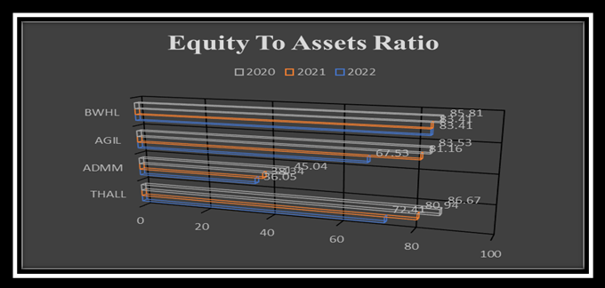

**INTERPRETATION:**

The equity-to-assets ratio for the years 2020, 2021, and 2022 shows the percentage of a company's assets funded by its owners rather than debt. In 2022, THALL had a ratio of 72.41%, ADMM had 36.05%, AGIL had 67.53%, and BWHL had 83.41%. Compared to the previous years, these ratios generally decreased for THALL and ADMM but remained relatively stable for AGIL and BWHL. Higher ratios suggest a larger share of assets financed by owners' equity, indicating lower financial risk. Understanding these ratios helps assess how companies use their own funds compared to external borrowing to support their operations and investments.

|  |  |  |  |  |
| --- | --- | --- | --- | --- |
| **Retention Ratio** | | | | |
|  | **THALL** | **ADMM** | **AGIL** | **BWHL** |
| **2022** | 85.72 | 74.32 | 100 | 35.97 |
| **2021** | 76.73 | 52.53 | 51.37 | 40.4 |
| **2020** | 78.3 | -121.66 | 0 | -5.72 |

**GRAPHICALLY:**

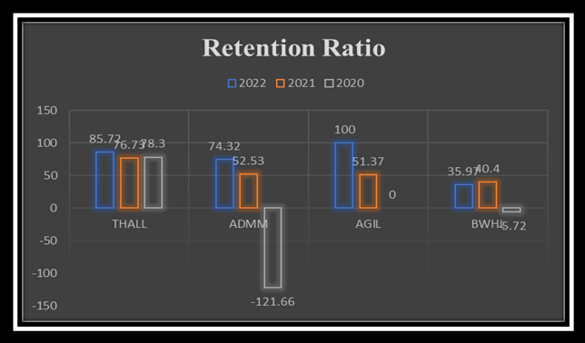

**INTERPRETATION:**

The retention ratio shows how much of a company's earnings it keeps after paying dividends. Looking at the provided data for four companies (THALL, ADMM, AGIL, BWHL) over the years 2020-2022, we see variations in their retention ratios. THALL generally retained a significant portion of its earnings, with ratios ranging from 76.73% to 85.72%. ADMM's ratios fluctuated, with a notably negative value in 2020, potentially indicating a net loss. AGIL retained all its earnings in 2022, while BWHL showed varying ratios, including a negative value in 2020. Negative ratios might suggest financial challenges or anomalies that require further investigation. Overall, these ratios provide insights into how much of a company's profits are reinvested for growth or held onto for various financial purposes

|  |  |  |  |  |
| --- | --- | --- | --- | --- |
| **Return on Assets** | | | | |
|  | **THALL** | **ADMM** | **AGIL** | **BWHL** |
| **2022** | 11.32 | 3.26 | 4.54 | 8.51 |
| **2021** | 11.79 | 2.02 | 12.04 | 4.42 |
| **2020** | 7.74 | 0.77 | -0.64 | 1.25 |

**GRAPHICALLY:**

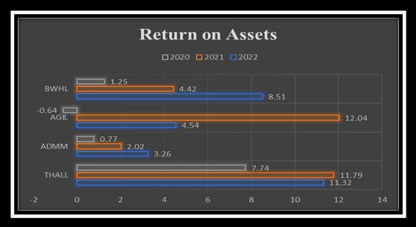

**INTERPRETATION:**

Return on Assets (ROA) is a financial measure that shows how well a company is making money from its investments in things like buildings, equipment, and other assets. In 2022, THALL had a 11.32% return, meaning they earned about 11 cents for every dollar of assets. ADMM earned 3.26%, AGIL made 4.54%, and BWHL had an 8.51% return in the same year. Higher percentages generally indicate better performance. In 2020, AGIL had a negative return, suggesting they might not have used their assets efficiently or had a loss that year. It's important for investors to look at ROA to understand how effectively a company is using its resources to generate profits.

|  |  |  |  |  |
| --- | --- | --- | --- | --- |
| **Return on Equity** | | | | |
|  | **THALL** | **ADMM** | **AGIL** | **BWHL** |
| **2022** | 15.63 | 9.04 | 6.72 | 10.2 |
| **2021** | 14.57 | 5.26 | 14.84 | 5.24 |
| **2020** | 8.93 | 1.72 | -0.76 | 1.46 |

**GRAHICALLY:**

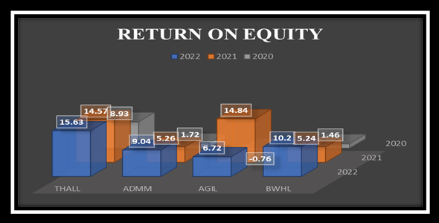

**INTERPRETATION:**

The Return on Equity (ROE) for the companies THALL, ADMM, AGIL, and BWHL has been calculated for the years 2020, 2021, and 2022. ROE represents the percentage of profit a company makes compared to its shareholders' equity. In 2022, THALL had an ROE of 15.63%, ADMM had 9.04%, AGIL had 6.72%, and BWHL had 10.2%. These values indicate how well each company is using its equity to generate profits for its shareholders. Generally, higher ROE is considered positive, suggesting effective use of equity, but a comprehensive analysis should consider other financial metrics and industry benchmarks.

|  |  |  |  |  |
| --- | --- | --- | --- | --- |
| **Dividend Yield Average** | | | | |
|  | **THALL** | **ADMM** | **AGIL** | **BWHL** |
| **2022** | 2.02 | 2.54 | 0 | 13.18 |
| **2021** | 2.38 | 2.16 | 4.82 | 6.06 |
| **2020** | 1.59 | 5.45 | 0.57 | 2.7 |

**GRAPHICALLY:**

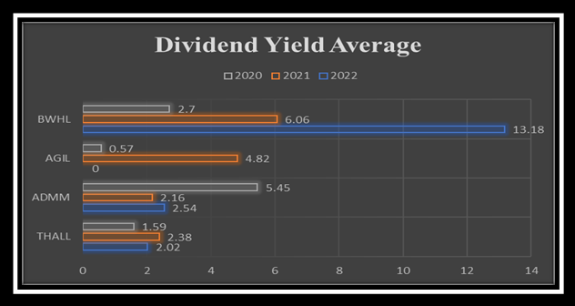

**INTERPRETATION:**

The average dividend yield, which represents the yearly income from investments, for THALL over the years 2020, 2021, and 2022 is 2.00%. For ADMM, the average is 3.38%, for AGIL, it is 1.80%, and for BWHL, it is 7.98%. This means that, on average, THALL pays out 2.00% of its stock value as dividends each year, ADMM pays out 3.38%, AGIL pays out 1.80%, and BWHL pays out 7.98%. These figures provide insights into the dividend-paying performance of each entity over the specified years.

|  |  |  |  |  |
| --- | --- | --- | --- | --- |
| **Payout Ratio** | | | | |
|  | **THALL** | **ADMM** | **AGIL** | **BWHL** |
| **2022** | 14.28 | 2.54 | 0 | 64.03 |
| **2021** | 23.27 | 2.16 | 48.63 | 59.6 |
| **2020** | 21.7 | 5.45 | -96.65 | 105.72 |

**GRAPHICALLY:**

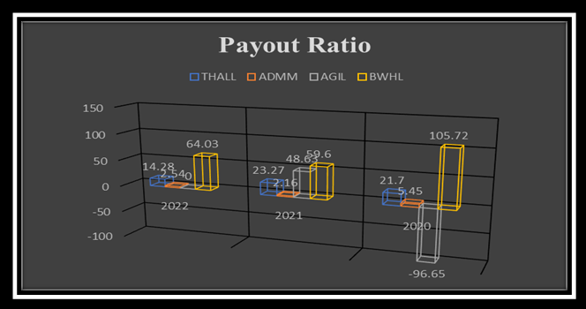

**INTERPRETATION:**

The payout ratio shows what percentage of a company's earnings is paid out to its shareholders as dividends. In 2022, THALL paid out 14.28% of its earnings as dividends, ADMM paid out 2.54%, AGIL did not pay any dividends (0%), and BWHL distributed 64.03% to its shareholders. In 2021, THALL's payout ratio was 23.27%, ADMM was 2.16%, AGIL was 48.63%, and BWHL was 59.6%. The data for 2020 reveals that THALL had a payout ratio of 21.7%, ADMM was 5.45%, AGIL had an unusual negative payout ratio of -96.65%, and BWHL distributed 105.72% of its earnings as dividends. A negative payout ratio may indicate specific financial circumstances that need further investigation.

|  |  |  |  |  |
| --- | --- | --- | --- | --- |
| **Gross Profit Margin** | | | | |
|  | **THALL** | **ADMM** | **AGIL** | **BWHL** |
| **2022** | 17.41 | 7.78 | 11.37 | 22.02 |
| **2021** | 17.09 | 11.33 | 13.44 | 15.43 |
| **2020** | 13.85 | 7.89 | 4.51 | 12.86 |

**GRAPHICALLY:**

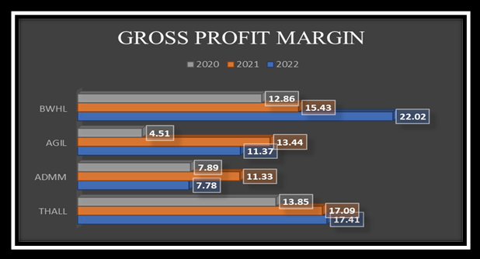 

**INTERPRETATION:**

The gross profit margin for different companies in 2022 is as follows: THALL 17.41%, ADMM 7.78%, AGIL 11.37%, and BWHL 22.02%. This metric represents the percentage of profit a company retains from its revenue after covering the costs of producing goods or services. A higher gross profit margin is generally favorable, indicating that a larger portion of revenue is turned into profit. Comparing these percentages across years helps assess each company's financial performance and their ability to maintain profitability.

|  |  |  |  |  |
| --- | --- | --- | --- | --- |
| **Operating Profit Margin** | | | | |
|  | **THALL** | **ADMM** | **AGIL** | **BWHL** |
| **2022** | 12.81 | 4.48 | 7.18 | 15.41 |
| **2021** | 118.84 | 7.09 | 8.97 | 6.37 |
| **2020** | 7.95 | 3.07 | 7.95 | -0.02 |

**GRAPHICALLY:**

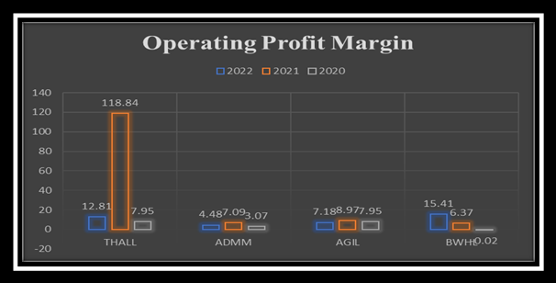

**INTERPRETATION:**

The operating profit margin, which shows the percentage of profit a company retains from its revenue after covering operating expenses, varied among four companies (THALL, ADMM, AGIL, BWHL) for the years 2020, 2021, and 2022. THALL had a significant increase in 2021, reaching 118.84%, but this might be an anomaly. In 2022, THALL's operating profit margin was 12.81%. ADMM had a modest decrease from 7.09% in 2021 to 4.48% in 2022. AGIL experienced a slight decline from 8.97% in 2021 to 7.18% in 2022. BWHL faced a challenging situation in 2020 with a negative operating profit margin of -0.02%, indicating an operating loss. Understanding these margins helps assess the companies' efficiency in managing costs and overall profitability.

|  |  |  |  |  |
| --- | --- | --- | --- | --- |
| **Net Profit Margin** | | | | |
|  |
|  | **THALL** | **ADMM** | **AGIL** | **BWHL** |  |
| **2022** | 11.4 | 4 | 3.39 | 7.5 |  |
| **2021** | 12.75 | 3.61 | 9.35 | 6.39 |  |
| **2020** | 11.35 | 1.43 | -0.79 | 2.07 |  |

**GRAPHICALLY:**

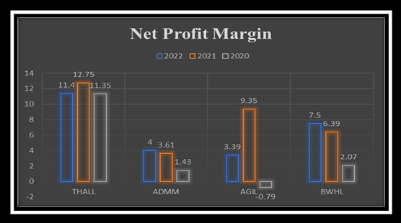

**INTERPRETATION:**

The net profit margin is a percentage that shows how much profit a company keeps from its total earnings. For 2022, THALL had a net profit margin of 11.4%, ADMM had 4%, AGIL had 3.39%, and BWHL had 7.5%. In 2021, THALL's net profit margin was 12.75%, ADMM's was 3.61%, AGIL's was 9.35%, and BWHL's was 6.39%. In 2020, THALL had an 11.35% net profit margin, ADMM had 1.43%, AGIL had -0.79%, and BWHL had 2.07%. These percentages indicate how efficiently each company is turning its revenue into profit, with higher percentages generally being more favorable.

|  |  |  |  |  |
| --- | --- | --- | --- | --- |
| **Assets Turnover** | | | | |
|  | **THALL** | **ADMM** | **AGIL** | **BWHL** |
| **2022** | 99.32 | 81.44 | 133.78 | 113.5 |
| **2021** | 92.49 | 55.93 | 128.86 | 69.2 |
| **2020** | 68.21 | 54.09 | 80.49 | 60.51 |

**GRAPHICALLY:**

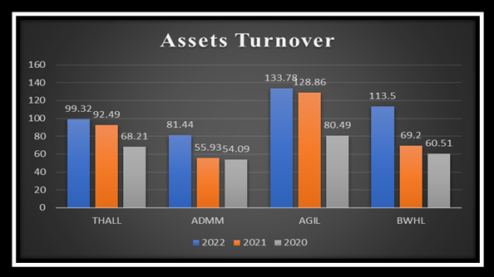

**INTERPRETATION:**

The assets turnover ratios for THALL, ADMM, AGIL, and BWHL have been increasing over the years 2020 to 2022. This indicates that these companies are getting better at using their assets to make money. Among them, AGIL has consistently high asset turnover, showing effective use of its resources. THALL and ADMM have also improved significantly, while BWHL has more than doubled its asset turnover from 2020 to 2021 and increased further in 2022. In simple terms, these trends suggest that the companies are becoming more efficient in turning their investments into revenue, which is generally seen as a positive sign by investors and stakeholders.

|  |  |  |  |  |
| --- | --- | --- | --- | --- |
| **Inventory Turnover** | | | | |
|  | **THALL** | **ADMM** | **AGIL** | **BWHL** |
| **2022** | 3.6 | 3.2 | 4.03 | 5.15 |
| **2021** | 3.53 | 1.92 | 6.59 | 4.58 |
| **2020** | 2.96 | 2.47 | 2.72 | 2.21 |

**GRAPHICALLY:**

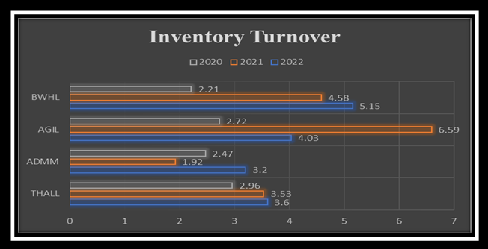

**INTERPRETATION:**

The inventory turnover for the companies THALL, ADMM, AGIL, and BWHL has been analyzed for the years 2020, 2021, and 2022. Generally, higher inventory turnover is considered good, indicating efficient inventory management. THALL and ADMM show increasing trends in turnover, suggesting improved efficiency in selling and replacing inventory. AGIL's turnover has decreased from 2021 to 2022, possibly due to changes in strategy or market conditions. BWHL has experienced an increase in turnover, indicating more efficient inventory management. Overall, understanding these trends helps assess how well each company is handling its inventory, a crucial aspect of effective business operations.

|  |  |  |  |  |
| --- | --- | --- | --- | --- |
| **Debt to Assets Ratio** | | | | |
|  | **THALL** | **ADMM** | **AGIL** | **BWHL** |
| **2022** | 8.12 | 51.16 | 11.96 | 1.43 |
| **2021** | 19.06 | 61.66 | 18.84 | 15.59 |
| **2020** | 13.33 | 54.96 | 16.47 | 14.19 |

**GRAPHICALLY:**

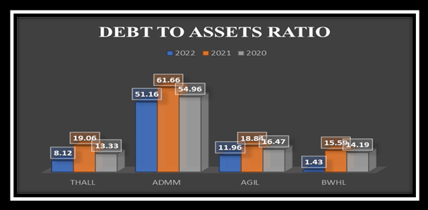

**INTERPRETATION:**

The Debt to Assets Ratio for the companies THALL, ADMM, AGIL, and BWHL has shown varying trends over the past three years. In 2022, THALL has the lowest ratio at 8.12, indicating that only 8.12% of its total assets are financed by debt. ADMM has a relatively high ratio of 51.16, suggesting that a significant portion of its assets is funded through debt. AGIL and BWHL fall in between, with ratios of 11.96 and 1.43, respectively. Comparing these ratios to the previous two years, there is a noticeable decrease for THALL and AGIL, possibly indicating a reduction in reliance on debt, while ADMM and BWHL show fluctuations. It's important to note that a lower ratio generally implies less financial risk, as the company has less debt relative to its assets, while a higher ratio may indicate higher financial leverage and potential risk. These variations in the Debt to Assets Ratio reflect differences in the companies' financial structures and strategies over the years.

**BALANCE SHEET ANALYSIS AMONG COMPETITOR:**

|  |  |  |  |  |
| --- | --- | --- | --- | --- |
| **BALANCE SHEET** | | | | |
| **YEAR** | **2022** | **2022** | **2022** | **2022** |
| **COMPANY** | **THALL** | **ADMM** | **AGIL** | **BWHL** |
| **Cash** | 2,557,628 | 2,096,373 | 67,147 | 66,034 |
| **Inventory** | 10,379,101 | 7,730,049 | 2,221,450 | 539,764 |
| **Current Asset** | 20,719,233 | 17,180,060 | 4,194,910 | 1,470,908 |
| **Investments** | 10,908,740 | 8,007,397 | 1,144,006 | 0 |
| **Fixed Asset** | 16,886,435 | 12,354,149 | 2,500,629 | 976,925 |
| **Total Assets** | 37,605,668 | 29,534,209 | 6,695,539 | 2,447,833 |
| **Current Liability** | 7,679,930 | 5,308,588 | 2,109,740 | 356,246 |
| **Fixed Liability** | 2,695,911 | 319,988 | 64,592 | 49,817 |
| **Total Liabilities** | 10,375,841 | 5,628,576 | 2,174,332 | 406,063 |
| **Paid Up Capital** | 405150 | 405150 | 180000 | 133343 |
| **Total Equity** | 27229827 | 23905633 | 4521207 | 2041770 |

**GRAPHICALLY:**

**INTERPRETATION:**

**Cash:**

THALL has the highest cash among the four companies, with $2,557,628.

ADMM follows with $2,096,373, AGIL has $67,147, and BWHL has $66,034.

**Inventory:**

THALL also leads in inventory, holding $10,379,101.

ADMM has $7,730,049, AGIL has $2,221,450, and BWHL has $539,764.

**Current Assets:**

THALL has the highest total current assets at $20,719,233.

ADMM follows with $17,180,060, AGIL has $4,194,910, and BWHL has $1,470,908.

**Investments:**

THALL and ADMM have significant investment values ($10,908,740 and $8,007,397, respectively).

AGIL has $1,144,006 in investments, while BWHL has none.

**Fixed Assets:**

THALL has the highest value in fixed assets at $16,886,435.

ADMM follows with $12,354,149, AGIL has $2,500,629, and BWHL has $976,925.

**Total Assets:**

THALL has the highest total assets among the four, amounting to $37,605,668.

ADMM follows with $29,534,209, AGIL has $6,695,539, and BWHL has $2,447,833.

**Current Liabilities:**

THALL has higher current liabilities at $7,679,930 compared to ADMM's $5,308,588, AGIL's $2,109,740, and BWHL's $356,246.

**Fixed Liabilities:**

THALL also has higher fixed liabilities at $2,695,911 compared to ADMM's $319,988, AGIL's $64,592, and BWHL's $49,817.

**Total Liabilities:**

THALL's total liabilities are higher at $10,375,841 compared to ADMM's $5,628,576, AGIL's $2,174,332, and BWHL's $406,063.

**Paid-Up Capital and Total Equity:**

THALL has the highest paid-up capital at $405,150 and the highest total equity at $27,229,827.

ADMM has the same paid-up capital but lower total equity at $23,905,633.

AGIL has a paid-up capital of $180,000 and total equity of $4,521,207.

BWHL has a paid-up capital of $133,343 and total equity of $2,041,770.

THALL generally outperforms the other three companies in terms of total assets, cash, inventory, and equity. ADMM follows closely, while AGIL and BWHL have relatively smaller financial figures across the board. It's important to note that this is a high-level overview, and a more in-depth analysis would require considering industry norms, profitability ratios, and other financial metrics.

|  |  |  |  |  |
| --- | --- | --- | --- | --- |
| **BALANCE SHEET** | | | | |
| **COMPANY** | **THALL** | **ADMM** | **AGIL** | **BWHL** |
| **YEAR** | **2021** | **2021** | **2021** | **2021** |
| **Cash** | 2,096,373 | 849,429 | 165,517 | 19,320 |
| **Inventory** | 7,730,049 | 5,553,816 | 1,056,905 | 343,671 |
| **Current Asset** | 17,180,060 | 12,879,592 | 3,236,150 | 1,311,824 |
| **Investments** | 8,007,397 | 5,795,615 | 1,144,006 | 0 |
| **Fixed Asset** | 12,354,149 | 11,236,265 | 2,172,795 | 963,935 |
| **Total Assets** | 29,534,209 | 24,115,857 | 5,408,945 | 2,275,759 |
| **Current Liability** | 5,308,588 | 3,063,886 | 1,005,642 | 284,467 |
| **Fixed Liability** | 319,988 | 150,818 | 13,305 | 70,396 |
| **Total Liabilities** | 5,628,576 | 3,214,704 | 1,018,947 | 354,863 |
| **Paid Up Capital** | 405,150 | 405,150 | 144,000 | 133,343 |
| **Total Equity** | 23,905,633 | 20,901,153 | 4,389,998 | 1,920,896 |

**GRAPHICALLY:**

**INTERPRETATION:**

**Total Assets:**

THALL has the highest total assets among the companies, standing at $29,534,209.

ADMM follows with $24,115,857, AGIL with $5,408,945, and BWHL with $2,275,759.

**Current Assets:**

THALL also leads in current assets, totaling $17,180,060.

ADMM has $12,879,592, AGIL has $3,236,150, and BWHL has $1,311,824.

This suggests THALL has more readily available resources like cash and inventory compared to the others.

**Total Equity:**

THALL again has the highest total equity at $23,905,633.

ADMM stands at $20,901,153, AGIL at $4,389,998, and BWHL at $1,920,896.

Total equity reflects the ownership value in the company and THALL has a greater stake compared to the others.

**Liabilities:**

THALL has the highest liabilities among the compared companies at $5,628,576.

ADMM follows with $3,214,704, AGIL with $1,018,947, and BWHL with $354,863.

This suggests THALL might have higher obligations or debts compared to the others.

**Fixed Assets:**

THALL's fixed assets stand at $12,354,149, the highest among the companies.

ADMM follows with $11,236,265, AGIL with $2,172,795, and BWHL with $963,935.

This indicates THALL has invested more in long-term assets like property or equipment.

**Paid-Up Capital:**

THALL has a paid-up capital of $405,150, similar to ADMM, higher than AGIL's $144,000, and BWHL's $133,343.

Overall, THALL appears to be the largest among the compared companies in terms of assets, equity, and current resources. However, it also holds higher liabilities, indicating a potentially larger financial commitment compared to the others.

|  |  |  |  |  |
| --- | --- | --- | --- | --- |
| **BALANCE SHEET** | | | | |
| **YEAR** | **2020** | **2020** | **2020** | **2020** |
| **COMPANY** | **THALL** | **ADMM** | **AGIL** | **BWHL** |
| **Cash** | 849,429 | 611,509 | 70,615 | 60,362 |
| **Inventory** | 5,553,816 | 5,635,305 | 1,385,313 | 413,575 |
| **Current Asset** | 12,879,592 | 12,470,222 | 2,515,891 | 1,086,124 |
| **Investments** | 5,795,615 | 5,431,550 | 1,144,006 | 0 |
| **Fixed Asset** | 11,236,265 | 8,752,407 | 2,166,484 | 422,535 |
| **Total Assets** | 24,115,857 | 21,222,629 | 4,682,375 | 1,508,659 |
| **Current Liability** | 3,063,886 | 2,589,707 | 762,263 | 140,629 |
| **Fixed Liability** | 150,818 | 1,463 | 8,712 | 73,376 |
| **Total Liabilities** | 3,214,704 | 2,591,170 | 770,975 | 214,005 |
| **Paid Up Capital** | 405,150 | 405,150 | 144,000 | 133,343 |
| **Total Equity** | 20,901,153 | 18,631,459 | 3,911,400 | 1,294,654 |

**GRAPHICALLY:**

**INTERPRETATION:**

**Cash:**

THALL has the highest cash reserves at $849,429, followed by ADMM with $611,509.

AGIL and BWHL have relatively lower cash amounts at $70,615 and $60,362, respectively.

**Inventory:**

THALL and ADMM have similar inventory levels, both exceeding $5.5 million.

AGIL has inventory worth $1,385,313, and BWHL has the lowest at $413,575.

**Current Assets:**

THALL has the highest current assets at $12,879,592, followed closely by ADMM at $12,470,222.

AGIL and BWHL have significantly lower current assets at $2,515,891 and $1,086,124, respectively.

**Investments:**

THALL and ADMM both have substantial investments, with THALL having the highest at $5,795,615.

AGIL has investments of $1,144,006, while BWHL does not have any reported investments.

**Fixed Assets:**

THALL has the highest fixed assets at $11,236,265.

ADMM follows with $8,752,407, AGIL with $2,166,484, and BWHL with the lowest at $422,535.

**Total Assets:**

THALL leads in total assets with $24,115,857, followed by ADMM with $21,222,629.

AGIL and BWHL have substantially lower total assets at $4,682,375 and $1,508,659, respectively.

**Current Liabilities:**

THALL and ADMM have relatively higher current liabilities at $3,063,886 and $2,589,707.

AGIL and BWHL have lower current liabilities at $762,263 and $140,629, respectively.

**Fixed Liabilities:**

THALL and AGIL have relatively low fixed liabilities.

BWHL has the highest fixed liabilities at $73,376.

**Total Liabilities:**

THALL has the highest total liabilities at $3,214,704, followed by ADMM at $2,591,170.

AGIL and BWHL have lower total liabilities at $770,975 and $214,005, respectively.

**Paid Up Capital:**

THALL, ADMM, and BWHL have similar paid-up capital, while AGIL has a lower amount.

**Total Equity:**

THALL has the highest total equity at $20,901,153.

ADMM follows with $18,631,459, AGIL with $3,911,400, and BWHL with $1,294,654.

In simple terms, THALL generally outperforms the other companies in terms of total assets, equity, and cash reserves. ADMM closely follows THALL, while AGIL and BWHL have comparatively smaller scales of operation and financial resources. It's essential to consider these factors when assessing the financial health and performance of each company.

**INCOME STATEMENT ANALYSIS AMONG COMPETITOR:**

|  |  |  |  |  |
| --- | --- | --- | --- | --- |
| **INCOME STATEMENT** | | | | |
| **COMPANY** | **THALL** | **ADMM** | **AGIL** | **BWHL** |
| **YEAR** | **2022** | **2022** | **2022** | **2022** |
| **Sales** | 16,448,479 | 16,352,907 | 8,957,545 | 2,778,192 |
| **Cost Of Sales** | 14,170,963 | 15,081,277 | 7,939,081 | 2,166,540 |
| **Gross Profit** | 2,277,516 | 1,271,630 | 1,018,464 | 611,652 |
| **Operating Profit** | 1,306,910 | 732,000 | 642,907 | 428,242 |
| **Other Income** | 1,408,276 | 640,796 | 31,843 | 52,514 |
| **Finance Cost** | 16,908 | 412,589 | 53,002 | 3,976 |
| **Profit Before Tax** | 2,371,606 | 883,305 | 458,428 | 425,374 |
| **Taxation** | 504,448 | 229,053 | 154,419 | 217,136 |
| **Profit After Tax** | 1,867,158 | 654,252 | 304,009 | 208,238 |

**GRAPHICALLY:**

**INTERPRETATION:**

**Sales:**

THALL has the highest sales at $16,448,479, followed closely by ADMM at $16,352,907. AGIL and BWHL have notably lower sales at $8,957,545 and $2,778,192, respectively.

**Gross Profit:**

THALL leads again in gross profit with $2,277,516. ADMM follows with $1,271,630, while AGIL and BWHL have lower figures at $1,018,464 and $611,652, respectively.

**Operating Profit:**

THALL maintains a higher operating profit of $1,306,910 compared to ADMM ($732,000), AGIL ($642,907), and BWHL ($428,242).

**Profit Before Tax:**

THALL has the highest profit before tax at $2,371,606, followed by ADMM ($883,305), AGIL ($458,428), and BWHL ($425,374).

**Profit After Tax:**

Similar trend continues in profit after tax, with THALL having the highest at $1,867,158, followed by ADMM ($654,252), AGIL ($304,009), and BWHL ($208,238).

|  |  |  |  |  |
| --- | --- | --- | --- | --- |
| **INCOME STATEMENT** | | | | |
| **COMPANY** | **THALL** | **ADMM** | **AGIL** | **BWHL** |
| **YEAR** | **2021** | **2021** | **2021** | **2021** |
| **Sales** | 22,374,364 | 9,813,176 | 6,969,981 | 1,574,822 |
| **Cost Of Sales** | 18,217,120 | 8,701,443 | 6,033,433 | 1,331,759 |
| **Gross Profit** | 4,157,244 | 1,111,733 | 936,548 | 243,063 |
| **Operating Profit** | 3,115,307 | 695,381 | 625,048 | 100,340 |
| **Other Income** | 1,521,134 | 103,980 | 262,894 | 55,940 |
| **Finance Cost** | 9,805 | 221,689 | 3,130 | 4,216 |
| **Profit Before Tax** | 4,334,642 | 456,356 | 834,049 | 141,568 |
| **Taxation** | 1,179,977 | 102,454 | 182,651 | 40,882 |
| **Profit After Tax** | 3,154,665 | 353,902 | 651,398 | 100,686 |

**GRAPHICALLY:**

**INTERPRETATION:**

**Sales Revenue:**

THALL had the highest sales revenue at $22,374,364, followed by ADMM at $9,813,176, AGIL at $6,969,981, and BWHL at $1,574,822.

**Cost of Sales:**

THALL also incurred the highest cost of sales at $18,217,120, followed by ADMM at $8,701,443, AGIL at $6,033,433, and BWHL at $1,331,759.

**Gross Profit:**

As a result, THALL maintained the highest gross profit of $4,157,244, followed by ADMM at $1,111,733, AGIL at $936,548, and BWHL at $243,063.

**Operating Profit:**

THALL's operating profit remained the highest among the group at $3,115,307, with ADMM at $695,381, AGIL at $625,048, and BWHL at $100,340.

**Other Income:**

In terms of other income, THALL recorded $1,521,134, while ADMM had $103,980, AGIL had $262,894, and BWHL had $55,940.

**Finance Cost:**

THALL had the lowest finance cost at $9,805, while ADMM incurred $221,689, AGIL had $3,130, and BWHL had $4,216.

**Profit Before Tax:**

THALL's profit before tax was significantly higher at $4,334,642 compared to ADMM's $456,356, AGIL's $834,049, and BWHL's $141,568.

**Taxation:**

THALL also paid the highest amount in taxes at $1,179,977, followed by ADMM at $102,454, AGIL at $182,651, and BWHL at $40,882.

**Profit After Tax:**

THALL ended up with the highest profit after tax of $3,154,665, whereas ADMM had $353,902, AGIL had $651,398, and BWHL had $100,686.

|  |  |  |  |  |
| --- | --- | --- | --- | --- |
| **INCOME STATEMENT** | | | | |
| **COMPANY** | **THALL** | **ADMM** | **AGIL** | **BWHL** |
| **YEAR** | **2020** | **2020** | **2020** | **2020** |
| **Sales** | 19,292,959 | 7,940,571 | 3,768,756 | 912,820 |
| **Cost Of Sales** | 15,631,677 | 7,314,029 | 3,598,810 | 795,406 |
| **Gross Profit** | 3,661,282 | 626,542 | 169,946 | 117,414 |
| **Operating Profit** | 2,627,797 | 243,433 | -126,996 | -158 |
| **Other Income** | 1,446,166 | 199,097 | 143,544 | 27,990 |
| **Finance Cost** | 8,869 | 166,747 | 2,991 | 2,353 |
| **Profit Before Tax** | 3,803,512 | 222,352 | 10,416 | 23,695 |
| **Taxation** | 1,117,542 | 108,662 | 40,214 | 4,775 |
| **Profit After Tax** | 2,685,970 | 113,690 | -29,798 | 18,920 |

**GRAPHICALLY:**

**INTERPRETATION:**

**Sales:**

THALL had the highest sales at $19,292,959.

ADMM followed with $7,940,571 in sales, AGIL with $3,768,756, and BWHL with $912,820.

**Cost Of Sales:**

THALL also had the highest cost of sales at $15,631,677.

ADMM had $7,314,029, AGIL had $3,598,810, and BWHL had $795,406.

**Gross Profit:**

THALL maintained the highest gross profit of $3,661,282.

ADMM had $626,542, AGIL had $169,946, and BWHL had $117,414.

**Operating Profit:**

THALL led with an operating profit of $2,627,797.

ADMM had $243,433, AGIL had a negative operating profit of -$126,996, and BWHL had a slightly negative figure of -$158.

**Other Income:**

THALL received $1,446,166 in other income, the highest among the compared companies.

ADMM had $199,097, AGIL had $143,544, and BWHL had $27,990.

**Finance Cost:**

THALL had the lowest finance cost at $8,869.

ADMM had $166,747, AGIL had $2,991, and BWHL had $2,353.

**Profit Before Tax:**

THALL had the highest profit before tax at $3,803,512.

ADMM had $222,352, AGIL had $10,416, and BWHL had $23,695.

**Taxation:**

THALL paid $1,117,542 in taxes.

ADMM paid $108,662, AGIL paid $40,214, and BWHL paid $4,775.

**Profit After Tax:**

THALL had a profit after tax of $2,685,970.

ADMM had $113,690, AGIL had a loss of -$29,798, and BWHL had a profit of $18,920.

THALL generally outperformed the other companies across most financial metrics in the year 2020. It had higher sales, gross profit, operating profit, other income, and profit before tax compared to ADMM, AGIL, and BWHL. However, while THALL had a positive profit after tax, AGIL reported a loss in that regard. THALL also managed its finance costs more efficiently than the other companies

**4- CASHFLOW ANALYSIS:**

Cash flow refers to the movement of money in and out of a business or individual's finances within a specific timeframe. It comprises cash coming in from various sources like sales, investments, or loans (inflows) and cash going out to cover expenses, investments, or debts (outflows). There are three main types: operating, investing, and financing cash flows. Positive cash flow indicates a healthy financial state, allowing for operational needs, investments, and debt payments, while negative cash flow might signal financial challenges or potential difficulties in meeting obligations or growth aspirations. Understanding and managing cash flow is crucial for sustainable financial health and effective planning for both businesses and individual.

* **THAL LIMITED CASHFLOW:**

|  |  |  |  |  |
| --- | --- | --- | --- | --- |
| **Cash Flow Statement** | | | | |
| **Operating Activities** | | | | |
| All values PKR Millions. | 2022 | 2021 | 2020 | 2019 |
| Net Income before Extraordinaries | 8,852 | 7,780 | 4,327 | 5,611 |
| Net Income Growth | 13.79% | 79.80% | -22.88% | - |
| Depreciation, Depletion & Amortization | 869 | 717 | 598 | 331 |
| Depreciation and Depletion | 807 | 653 | 552 | 320 |
| Other Funds | -3,000 | -3,424 | -1,583 | -1,632 |
| Funds from Operations | 6,722 | 5,073 | 3,342 | 4,310 |
| Changes in Working Capital | -3,220 | -1,857 | 19 | -2,870 |
| Receivables | -829 | -1,101 | -287 | -1,117 |
| Inventories | -2,776 | -2,189 | -165 | -1,738 |
| Accounts Payable | 1,600 | 1,801 | 302 | 150 |
| Other Assets/Liabilities | -1,201 | -353 | 125 | -121 |
| Net Operating Cash Flow | 3,502 | 3,216 | 3,361 | 1,440 |
| Net Operating Cash Flow Growth | 8.90% | -4.33% | 133.40% | - |
| Net Operating Cash Flow / Sales | 8.80% | 10.85% | 19.37% | 6.12% |
| **Investing Activities** | | | | |
| All values PKR Millions. | 2022 | 2021 | 2020 | 2019 |
| Capital Expenditures | -2,735 | -1,134 | -1,529 | -1,950 |
| Capital Expenditures (Fixed Assets) | -2,722 | -1,122 | -1,398 | -1,864 |
| Capital Expenditures (Other Assets) | -13 | -12 | -131 | -86 |
| Capital Expenditures Growth | -141.23% | 25.84% | 21.59% | - |
| Capital Expenditures / Sales | -6.87% | -3.83% | -8.81% | -8.28% |
| Sale of Fixed Assets & Businesses | 44 | 75 | 19 | 54 |
| Net Investing Cash Flow | -4,408 | -3,550 | -2,401 | -1,563 |
| Net Investing Cash Flow Growth | -24.19% | -47.87% | -53.56% | - |
| Net Investing Cash Flow / Sales | -11.07% | -11.98% | -13.83% | -6.64% |
| **Financing Activities** | | | | |
| All values PKR Millions. | 2022 | 2021 | 2020 | 2019 |
| Cash Dividends Paid - Total | -1,317 | -956 | -915 | -1,151 |
| Common Dividends | -1,317 | -956 | -915 | -1,151 |
| Issuance/Reduction of Debt, Net | 2,681 | 354 | 569 | 274 |
| Change in Current Debt | 236 | 338 | 344 | 274 |
| Change in Long-Term Debt | 926 | - | 225 | - |
| Issuance of Long-Term Debt | 926 | - | 225 | - |
| Net Financing Cash Flow | 1,345 | -602 | -354 | -877 |
| Net Financing Cash Flow Growth | 323.50% | -70.08% | 59.67% | - |
| Net Financing Cash Flow / Sales | 3.38% | -2.03% | -2.04% | -3.73% |
| Net Change in Cash | 439 | -936 | 607 | -1,000 |
| Free Cash Flow | 780 | 2,094 | 1,963 | -424 |
| Free Cash Flow Growth | -62.75% | 6.64% | 563.55% | - |
| Free Cash Flow Yield | - | - | - | - |

* **ARTISTIC DENIM MILLS CASHFLOW:**

|  |  |  |  |  |
| --- | --- | --- | --- | --- |
| **Cash Flow Statement** | | | | |
| **Operating Activities** | | | | |
| All values PKR Millions. | 2022 | 2021 | 2020 | 2019 |
| Net Income before Extra ordinaries | 883 | 456 | 222 | 955 |
| Net Income Growth | 93.56% | 105.24% | -76.73% | - |
| Depreciation, Depletion & Amortization | 532 | 506 | 497 | 461 |
| Depreciation and Depletion | 530 | 505 | 495 | - |
| Other Funds | -8 | 36 | -34 | -48 |
| Funds from Operations | 1,407 | 999 | 685 | 1,368 |
| Changes in Working Capital | -383 | -2,604 | -320 | -1,101 |
| Receivables | -520 | -1,005 | 271 | -449 |
| Inventories | 57 | -1,948 | -790 | -735 |
| Accounts Payable | 113 | 402 | 238 | 51 |
| Other Assets/Liabilities | -6 | -53 | -38 | 32 |
| Net Operating Cash Flow | 1,025 | -1,605 | 365 | 268 |
| Net Operating Cash Flow Growth | 163.82% | -539.50% | 36.45% | - |
| Net Operating Cash Flow / Sales | 6.05% | -16.36% | 4.60% | 3.45% |
| **Investing Activities** | | | | |
| All values PKR Millions. | 2022 | 2021 | 2020 | 2019 |
| Capital Expenditures | -2,430 | -2,178 | -683 | -1,075 |
| Capital Expenditures (Fixed Assets) | -2,430 | -2,178 | -683 | -1,075 |
| Capital Expenditures Growth | -11.61% | -218.94% | 36.50% | - |
| Capital Expenditures / Sales | -14.35% | -22.19% | -8.60% | 13.84% |
| Sale of Fixed Assets & Businesses | 2 | 9 | 31 | 20 |
| Sale/Maturity of Investments | - | 1,213 | 39 | - |
| Net Investing Cash Flow | -2,429 | -956 | -1,954 | -1,094 |
| Net Investing Cash Flow Growth | -154.04% | 51.08% | -78.56% | - |
| Net Investing Cash Flow / Sales | -14.34% | -9.74% | -24.61% | -14.09% |
| **Financing Activities** | | | | |
| All values PKR Millions. | 2022 | 2021 | 2020 | 2019 |
| Cash Dividends Paid - Total | -168 | -252 | -252 | -210 |
| Common Dividends | -168 | -252 | -252 | -210 |
| Issuance/Reduction of Debt, Net | 1,830 | 2,300 | 1,528 | 2,146 |
| Change in Current Debt | 722 | 1,274 | 1,162 | 1,495 |
| Change in Long-Term Debt | 1,108 | 1,026 | 366 | 651 |
| Issuance of Long-Term Debt | 1,326 | 1,070 | 447 | 753 |
| Net Financing Cash Flow | 1,663 | 2,048 | 1,276 | 1,937 |
| Net Financing Cash Flow Growth | -18.80% | 60.42% | -34.10% | - |
| Net Financing Cash Flow / Sales | 9.82% | 20.87% | 16.07% | 24.94% |
| Net Change in Cash | 258 | -514 | -313 | 1,110 |
| Free Cash Flow | -1,406 | -3,783 | -318 | -808 |
| Free Cash Flow Growth | 62.84% | -1091.33% | 60.68% | - |
| Free Cash Flow Yield | - | - | - | - |

* **AGRIAUTOS INDUSTRIES LIMITED:**

|  |  |  |  |  |
| --- | --- | --- | --- | --- |
| **Cash Flow Statement** | | | | |
| **Operating Activities** | | | | |
| All values PKR Millions. | 2022 | 2021 | 2020 | 2019 |
| Net Income before Extraordinaries | 1,105 | 1,203 | -25 | 1,257 |
| Net Income Growth | -8.20% | 4919.04% | -101.99% | - |
| Depreciation, Depletion & Amortization | 334 | 296 | 291 | 194 |
| Depreciation and Depletion | 319 | 281 | 280 | 192 |
| Other Funds | -332 | -274 | -32 | -417 |
| Funds from Operations | 1,106 | 1,225 | 235 | 1,034 |
| Changes in Working Capital | -1,505 | -867 | 624 | -812 |
| Receivables | -67 | -526 | 411 | -412 |
| Inventories | -2,100 | 202 | -333 | -173 |
| Accounts Payable | - | - | 350 | 109 |
| Other Assets/Liabilities | 668 | -579 | 196 | -337 |
| Net Operating Cash Flow | -398 | 358 | 859 | 222 |
| Net Operating Cash Flow Growth | -211.27% | -58.31% | 287.38% | - |
| Net Operating Cash Flow / Sales | -2.59% | 3.42% | 16.38% | 2.19% |
| **Investing Activities** | | | | |
| All values PKR Millions. | 2022 | 2021 | 2020 | 2019 |
| Capital Expenditures | -882 | -435 | -432 | -713 |
| Capital Expenditures (Fixed Assets) | -882 | -435 | -432 | -713 |
| Capital Expenditures Growth | -102.57% | -0.83% | 39.44% | - |
| Capital Expenditures / Sales | -5.73% | -4.15% | -8.23% | -7.04% |
| Sale of Fixed Assets & Businesses | 15 | 54 | 21 | 14 |
| Sale/Maturity of Investments | 9 | 82 | 26 | - |
| Net Investing Cash Flow | -858 | -300 | -385 | -752 |
| Net Investing Cash Flow Growth | -186.31% | 22.16% | 48.81% | - |
| Net Investing Cash Flow / Sales | -5.57% | -2.86% | -7.34% | -7.42% |
| **Financing Activities** | | | | |
| All values PKR Millions. | 2022 | 2021 | 2020 | 2019 |
| Cash Dividends Paid - Total | -172 | -171 | -200 | -327 |
| Common Dividends | -172 | -171 | -200 | -327 |
| Issuance/Reduction of Debt, Net | 123 | - | - | - |
| Change in Long-Term Debt | 123 | - | - | - |
| Issuance of Long-Term Debt | 127 | - | - | - |
| Reduction in Long-Term Debt | -4 | - | - | - |
| Net Financing Cash Flow | -58 | -178 | -208 | -327 |
| Net Financing Cash Flow Growth | 67.27% | 14.77% | 36.29% | - |
| Net Financing Cash Flow / Sales | -0.38% | -1.69% | -3.97% | -3.23% |
| Net Change in Cash | -1,314 | -119 | 266 | -857 |
| Free Cash Flow | -1,280 | -77 | 427 | -491 |
| Free Cash Flow Growth | -1557.31% | -118.09% | 186.96% | - |
| Free Cash Flow Yield | - | - | - | - |

* **BALOCHISTAN WHEELS LIMITED CASHFLOW:**

|  |  |  |  |  |
| --- | --- | --- | --- | --- |
| **Cash Flow Statement** | | | | |
| **Operating Activities** | | | | |
| All values PKR Millions. | 2022 | 2021 | 2020 | 2019 |
| Net Income before Extraordinaries | 425,374.00 | 141,568.00 | 23,695.00 | 93,955.00 |
| Net Income Growth | 200.47% | 497.46% | -74.78% | - |
| Depreciation, Depletion & Amortization | 50,617.00 | 48,931.00 | 51,448.00 | 50,323.00 |
| Depreciation and Depletion | 50,617.00 | 48,931.00 | 51,448.00 | 50,323.00 |
| Other Funds | -24,135.00 | 18,800.00 | 17,568.00 | -2,561.00 |
| Funds from Operations | 451,856.00 | 209,299.00 | 92,711.00 | 141,717.00 |
| Changes in Working Capital | -234,587.00 | -26,287.00 | 148,781.00 | 18,029.00 |
| Receivables | 6,903.00 | -177,374.00 | 26,142.00 | 26,035.00 |
| Inventories | -202,387.00 | 81,607.00 | 123,728.00 | 8,464.00 |
| Accounts Payable | -55,852.00 | 110,310.00 | 5,365.00 | -15,372.00 |
| Other Assets/Liabilities | 16,749.00 | -40,830.00 | -6,454.00 | -1,098.00 |
| Net Operating Cash Flow | 217,269.00 | 183,012.00 | 241,492.00 | 159,746.00 |
| Net Operating Cash Flow Growth | 18.72% | -24.22% | 51.17% | - |
| Net Operating Cash Flow / Sales | 7.82% | 11.62% | 26.46% | 10.06% |
| **Investing Activities** | | | | |
| All values PKR Millions. | 2022 | 2021 | 2020 | 2019 |
| Capital Expenditures | -25,335.00 | -9,804.00 | -4,041.00 | -7,980.00 |
| Capital Expenditures (Fixed Assets) | -25,335.00 | -9,804.00 | -4,041.00 | -7,980.00 |
| Capital Expenditures Growth | -158.41% | -142.61% | 49.36% | - |
| Capital Expenditures / Sales | -0.91% | -0.62% | -0.44% | -0.50% |
| Sale of Fixed Assets & Businesses | 1,999.00 | 39,340.00 | 1,546.00 | 6,133.00 |
| Sale/Maturity of Investments | 2,156,840.00 | 1,507,794.00 | 523,926.00 | 63,461.00 |
| Net Investing Cash Flow | -5,436.00 | -187,132.00 | -233,093.00 | -101,603.00 |
| Net Investing Cash Flow Growth | 97.10% | 19.72% | -129.42% | - |
| Net Investing Cash Flow / Sales | -0.20% | -11.88% | -25.54% | -6.40% |
| **Financing Activities** | | | | |
| All values PKR Millions. | 2022 | 2021 | 2020 | 2019 |
| Cash Dividends Paid - Total | -128,987.00 | -19,848.00 | -27,602.00 | -38,438.00 |
| Common Dividends | -128,987.00 | -19,848.00 | -27,602.00 | -38,438.00 |
| Issuance/Reduction of Debt, Net | -21,396.00 | -9,374.00 | 42,786.00 | -5,827.00 |
| Change in Long-Term Debt | -21,396.00 | -9,374.00 | - | - |
| Reduction in Long-Term Debt | -21,396.00 | -9,374.00 | - | - |
| Net Financing Cash Flow | -165,119.00 | -36,922.00 | 6,969.00 | -44,265.00 |
| Net Financing Cash Flow Growth | -347.21% | -629.80% | 115.74% | - |
| Net Financing Cash Flow / Sales | -5.94% | -2.34% | 0.76% | -2.79% |
| Net Change in Cash | 46,714.00 | -41,042.00 | 15,368.00 | 13,878.00 |
| Free Cash Flow | 191,934.00 | 173,208.00 | 237,451.00 | 151,766.00 |
| Free Cash Flow Growth | 10.81% | -27.06% | 56.46% | - |
| Free Cash Flow Yield | - | - | - | - |

**INTERPRETATION:**

**THAL Limited**

**Operating Activities:**

Consistent positive net operating cash flow.

Healthy growth in net income and funds from operations over the years.

Varying changes in working capital affecting cash flow.

**Investing Activities:**

Consistently negative net investing cash flow.

Capital expenditures fluctuate but mostly negative, indicating significant investment in assets.

Limited sale of fixed assets.

**Financing Activities:**

Positive net financing cash flow.

Shows an increase in debt issuance.

Steady dividend payments.

**Artistic Denim MillS**

**Operating Activities:**

Significant fluctuations in net operating cash flow.

Drastic changes in working capital affecting cash flow negatively.

**Investing Activities:**

Consistently negative net investing cash flow.

Capital expenditures significantly fluctuate.

**Financing Activities:**

Positive net financing cash flow.

Varying trends in debt-related activities.

Dividend payments show inconsistency.

**Agri Autos Industries Limited**

**Operating Activities:**

Highly fluctuating net operating cash flow over the years.

Severe changes in working capital influencing cash flow negatively.

**Investing Activities:**

Negative net investing cash flow, fluctuating but mostly negative.

Capital expenditures varying but generally negative.

**Financing Activities:**

Negative net financing cash flow in some years.

Notable changes in dividend payments and debt-related activities.

Balochistan Wheels Limited

**Operating Activities:**

Massive net income growth, with fluctuations in cash flow.

Changes in working capital significantly impact cash flow.

**Investing Activities:**

Fluctuating net investing cash flow, ranging from positive to highly negative.

Significant investment in fixed assets and occasional large sales of investments.

**Financing Activities:**

Consistent negative net financing cash flow.

Large dividend payments.

Reduction in long-term debt.

THAL Limited showcases a comparatively stable cash flow across operating, investing, and financing activities, indicating a balanced financial position.

Its competitors show more volatile cash flows, especially in operating and investing activities, potentially indicating higher business risk or different investment strategies.

THAL Limited’s consistent positive net operating cash flow and relatively stable financing activities might reflect a more steady and sustainable financial performance compared to its competitors.

4- **CHAIRMAN REVIEW:**

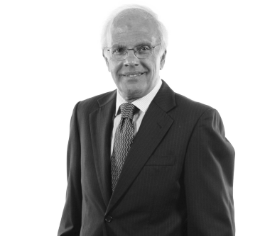

Thal Restricted has closed an effective year in spite of worldwide difficulties, denoting a 34% increment in deals and a benefit after tax collection from Rs. 6.3 Billion. Their Auto-Designing fragment saw a 42% deals development because of the roaring car industry. Bundling and Building Materials portion, including Thal Jute and Bundling divisions, became by 29% credited to expanded send out deals and fruitful product offerings.

The organization's undertakings, as Formite, endured market pressures and stayed beneficial regardless of money downgrading. In the property area, Habib METRO delivered profits and is investigating development choices. SECMC and ThalNova under the energy area are working without a hitch and going for the gold creation by 2023.

Expecting moves in FY23 because of expansion, import limitations, and normal disasters, Thal Restricted plans to upgrade its product impression, center around cost efficiencies, and confine unrefined components. Their endeavors in representative turn of events, wellbeing, and natural maintainability have been imperative, with interests in learning programs and a decrease of the carbon impression by 2%.

The organization offers thanks to the Board, panels, staff, accomplices, and vendors for outperforming assumptions. They expect to confront impending difficulties by and large, guaranteeing a manageable future for the organization and the country.

Thal Restricted's yearly report for 2021-2022 will be fundamentally accessible online as a component of their obligation to lessening their carbon impression and utilizing assets productively.

5- **SWOT ANALYSIS:**

**Strengths:**

* **Revenue Growth:** Significant revenue growth over the past three years indicates market traction and potential.
* **Gross Income Increase:** Consistent growth in gross income reflects effective cost management or increased sales.
* **EBITDA Growth**: Substantial growth in EBITDA implies operational efficiency and improved profitability.

**Weaknesses:**

* **Declining Profit Margins:** Despite revenue growth, declining profit margins may signify increased costs or pricing pressure.
* **Inconsistent Net Income Growth:** Inconsistent net income growth indicates potential instability in earnings or cost inefficiencies.

**Opportunities:**

* **Market Expansion:** The consistent revenue growth presents an opportunity to explore new markets or expand existing ones.
* **Cost Optimization:** Analyzing cost components to improve margins and streamline operations

**Threats:**

* **Rising Costs:** Increasing costs, especially in COGS and SG&A, might impact profitability negatively.
* **Market Competition:** Intense market competition could pose a threat to sustaining growth and margins.
* **Economic Uncertainty:** Economic fluctuations or instability could affect consumer spending and overall market conditions.

This SWOT investigation gives a depiction of Thal Restricted's position in light of its monetary presentation. It's vital to supplement this examination with non-monetary viewpoints, for example, market patterns, industry changes, and key drives to get a complete comprehension of the organization's situation.

6- **IMPACT OF INFLATION RATE , INTEREST RATE , IMPORT , EXPORT AND BUDGET DEFICIT:**

**Inflation Rate:**

Automobile Parts and Accessories: The inflation rate in Pakistan had been fluctuating during these years. Higher inflation generally leads to increased costs of production and higher prices for consumers. This could have impacted the automobile parts and accessories sector by raising the cost of raw materials, manufacturing, and transportation, potentially resulting in increased prices for consumers.

**Jute Packaging:** Inflation might have affected the cost of jute production and processing, leading to increased prices for jute packaging materials. This could have affected the overall cost structure for industries relying on jute packaging.

**Lamination Sector:** Similarly, inflation might have influenced the cost of raw materials used in lamination, impacting the overall cost structure for this sector.

**Interest Rate:**

Automobile Parts and Accessories: Changes in interest rates can impact borrowing costs for manufacturers. If interest rates were high, it could have increased the cost of capital for automobile parts and accessories manufacturers, potentially affecting investment and expansion plans.

Jute Packaging and Lamination: Both sectors might have faced challenges in accessing affordable loans or credit facilities if interest rates were high, impacting their growth and investment opportunities.

**Import and Export:**

**Automobile Parts and Accessories:** Fluctuations in import and export could have affected the availability and cost of imported parts for the automobile industry. Changes in trade policies, tariffs, or currency fluctuations could have influenced these sectors' competitiveness and profitability.

**Jute Packaging and Lamination:** Changes in import and export policies might have affected the availability and cost of raw materials for these sectors. Export demand for finished products could have also been impacted by global trade dynamics.

**Budget Deficit:**

A higher budget deficit could lead to increased government borrowing, potentially crowding out private investment and impacting overall economic growth. Sectors reliant on government spending or subsidies might have been affected if the deficit constrained government expenditures.

**Reasons Behind Scenarios:**

Several factors could have contributed to these scenarios:

**Global Economic Conditions:** The global economic situation, especially amid the COVID-19 pandemic, significantly influenced trade, inflation, and interest rates worldwide, impacting Pakistan's economy.

**Government Policies:** Changes in government policies regarding trade, fiscal measures, and monetary policy could have influenced inflation rates, interest rates, and trade dynamics.

**Supply Chain Disruptions:** Disruptions in global supply chains due to the pandemic or other factors might have affected the availability and cost of raw materials for these sectors.

**Exchange Rate Fluctuations:** Changes in the exchange rate could impact import costs for raw materials and affect export competitiveness for finished products.

Each sector's specific challenges and opportunities would have been shaped by a combination of these factors, and their responses would vary based on their individual circumstances, market demands, and adaptability to changing economic conditions.

7- **REASONS FOR INVESTING IN PORTFOLIO:**

When considering investing in Thal Limited's portfolio, several factors might influence the decision:

* **Company Fundamentals:** Thal Limited's financial health, growth prospects, market position, and management quality are crucial. Positive indicators might include strong revenue growth, profitability, innovative products/services, and a solid track record.
* **Industry and Market Outlook:** Evaluating the industry in which Thal Limited operates is essential. Positive industry trends, low competition, and a promising market outlook could make it an attractive investment.
* **Diversification Benefits:** If Thal Limited's portfolio offers a diverse range of assets across different sectors or investment types, it could provide risk mitigation and potential for varied returns.
* **Risk-Return Profile:** Assessing the risk associated with Thal Limited's portfolio is crucial. Balancing the potential returns against the level of risk and volatility is a key consideration.
* **Dividend Yield or Growth Potential:** If Thal Limited has a history of paying dividends or shows promising growth potential, it could attract investors seeking income or capital appreciation.
* **Corporate Governance and Ethical Considerations:** Investors often evaluate a company's ethical stance, governance practices, and social responsibility. Positive corporate behavior can influence investment decisions.
* **Market Conditions and Economic Outlook:** Analyzing broader economic factors and market conditions helps determine whether the timing is favorable for investing in Thal Limited's portfolio.
* **Long-Term Strategy:** If Thal Limited has a clear and viable long-term strategy aligned with your investment goals, it might be a compelling choice.

Ultimately, the decision to invest in Thal Limited's portfolio would depend on thorough research, an understanding of its assets, risk tolerance, and alignment with your investment objective.

CREATED BY: **SYED DANIYAL HUSSAIN**

SEAT NO: **EB-20202079**